**Experiment 4**

**Aim:**

To write an ARM Assembly Language to

1. Add two 64 bit numbers.
2. Add ten 32 bit numbers.

**Tool Used:**

Keil uVision4

**Theory:**

LDM load multiple register locations with starting address mentioned. ! is used in LDM for updating pointer, else same value will be updated in all registers. STM load the value into consecutive memory locations with starting address mentioned. ADDCS adds the value if the carry flag is set.

**a) Add two 64 bit numbers.**

**Code:**

 AREA PROGRAM,CODE, READONLY

 ENTRY

MAIN

 LDR R0, =0X00000000

 LDM R0!, {R1-R4}

 ADDS R6,R2,R4

 ADCS R5,R1,R3

 LDR R7, =0X00000010

 STM R7!, {R5-R6}

 END

**Output:**

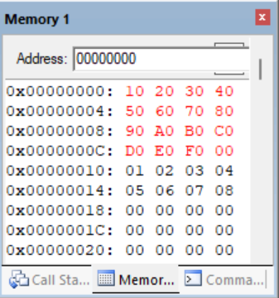

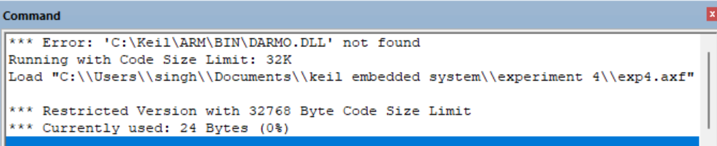

**Register Contents**

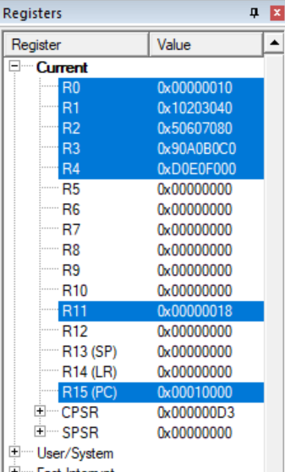

**b) Add Ten 32 bit numbers.**

**Code:**

 AREA PROGRAM,CODE, READONLY

 ENTRY

MAIN

    LDR R0, =0x00000000

    LDR R1, =0x00000020

    MOV R3, #9

    LDR R4, [R0]

LOOP ADD R0, R0, #4

    LDR R5, [R0]

    ADDS R4,R4,R5

    ADCS R7,R7,#1

    SUBS R3,R3,#1

    BNE LOOP

    STR R4, [R1], #4

    STR R7, [R1]

    END

**Output:**

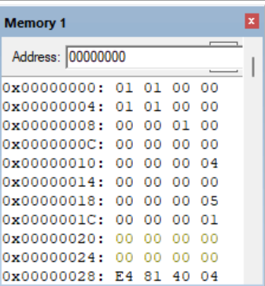

**Register Contents**

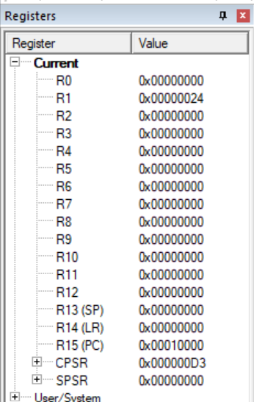

**Result:**

The experiments on add operations have been performed and verified to be correct.